Multivariate Statistics (MARS6300) - Homework 6 Name: _______________________
Distributed: Tuesday, March 13, 2018 Due: Thursday, April 5, 2018
Instructions: Copy and paste your answers below and turn in a word file and two excel files by the end of due day via email to khyrenba@gmail.com. Please use email title “MARS 6300 hw#6” and label all files with you’re a suffix including your name (e.g., MARS6300_hw6_hyrenbach). Unlabeled emails / files will be penalized 10% of points.
You are free to use any reference materials of your choice. While you are encouraged to work together, make sure you turn your own assignment. This homework is worth 5 points. Make sure you leave the formulas showing all of your calculations in the excel file, and explain your reasoning, to get partial credit.

The objectives of this homework are:
A) To critically evaluate the MANOVA literature
B) To perform and interpret an MRPP analysis.
C) To perform and interpret a MANOVA analysis.

To complete this homework, you will need:
- Instruction file: “MARS6300_hw6.doc” (open with word file) – Turn this file in
- “Biogeography_samples.xls” and “Biogeography_groups.xls”
- One pdf: Anderson 2001

- MRPP Analysis:
- You will perform the MRPP analysis in two ways: (i) first, you will use the grouping variable SST (in matrix 2), to identify three groups, and (ii) you will select one of the indicator species you identified in the last homework, to define groups.

- To compare the groups of samples defined using SST, do the following: import: “Biogeography_samples.xls” as matrix 1 and “Biogeography_groups.xls” as matrix 2. Perform the MRPP analysis using the set-up recommended in class – rank transform distance metric, and the recommended approach for weighing groups.
Paste the results header, showing the set-up of the test below:

Report the following:

Test statistic: T =
Observed delta =
Expected delta =
Variance of delta =
Skewness of delta =

- Interpret the Test statistic T: What does the negative sign mean?

- What is the probability (p value) ?

- Is this a significant result?

- What groups are responsible for the significant pattern?

- ISA Analysis:

- Perform the ISA analysis to determine which species are responsible for the significant differences you found with the MRPP test performed above (question 1)?

- Copy and paste the Indicator Values for the 47 species (for all three water masses) below:

- Using these results, classify the 47 species as having one biogeographic affinity:
(Note: explain the rule you are using to make this classification below, and then list the species acronyms below, within each biogeographic classification)

Explain your RULE here:

  - Subtropical (group 1):

  - Northern convergence (group 1 and 2):

  - Convergence (group 2):

  - Southern convergence (group 2 and 3):

  - Sub-Antarctic (group 3):

  - Cosmopolitan (widely distributed):

- Finally, paste the randomization significance results below, and indicate how many of these species were significant indicators for each of the three groups you identified?

- Question: were any of the cosmopolitan species significant indicators? Why / why not?

- To finish this exercise, redo the MRPP analysis a second time. This time, use the presence – absence of one of the indicator species you identified in the previous homework (#5) to define two groups in matrix 2.

- Note: You will analyze the data in matrix 1 (“Biogeography_samples.xls”) using the presence / absence of the indicator species as the criterion for defining the groups. To do this, select the grouping variable from the first matrix.

- DO THIS ONLY ONCE: pick whichever species you think is the best indicator for a specific water mass. Report what species you selected and what water mass does it indicate: _________________

- Report the results of the MRPP test below:

Test statistic: T =
Observed delta =
Expected delta =
Variance of delta =
Skewness of delta =

- Interpret the Test statistic T: What does the negative sign mean?

- What is the probability (p value) ?

- Is this a significant result?

- Are you surprised of this result? Explain why / why not?

- You have five groups of samples (5 in each), with the abundance of three species (see table 2 below). Enter this information into two matrices in PC-ORD (1: a data matrix; 2: a grouping matrix) and perform an MRPP test to determine which groups and species are significantly different.
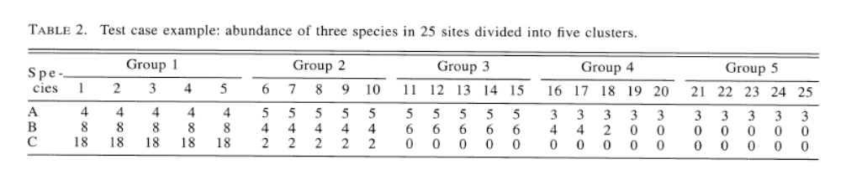
- First of all, calculate the indicator values of each species in each group, as the product of the “fidelity” and the “specificity” values:

 | Group1 | Group2 | Group3 | Group4 | Group5
SpA - fidelity | 5 / 5 = 1
SpA- specificity | 4 / 20 = 0.2
SpA- Indicator Value | 0.20
SpB - fidelity
SpB - specificity
SpB - Indicator Value
SpC - fidelity
SpC - specificity
SpC - Indicator Value

- List which samples (1, 2, 3, 4, 5) are best indicated by the three species:
Species A: _______ Species B: ________ Species c: __________

- Now that you have calculated the indicator species values, perform the MRPP test, using 5 groups. Report the results below:

Test statistic: T =
Observed delta =
Expected delta =
Variance of delta =
Skewness of delta =

- Interpret the Test statistic T: What does the negative sign mean?

- What is the probability (p value) ?

- Is this a significant result?

Finally, perform an ISA in PC-ORD to see which species are responsible for these differences and report the following:

Species | Indicator Value | P Value
A
B
C

Do your scores agree with the PC-ORD Indicator Values? Explain Why / Why Not?

- Read and Evaluate Anderson 2001

Focus on the section “ECOLOGICAL EXAMPLES”, and for each of these approaches, create a matrix showing how you would organize your samples (like it was shown in class) to obtain the correct sample design. Hint: You do not need to include the species data, just show how you would arrange each of the treatments and replicates to re-create the experimental design discussed in the particular example. Label factors and replicates in separate columns

- Two way factorial design:

- Three way design, including nesting:

- Perform MANOVA analysis:

Enter the following data into the main matrix of PC-ORD and develop a secondary matrix for the grouping of the data, using two separate groups (factors). Use Relative Sorensen and ask for group-comparisons and randomization tests.

Two-Way analysis: 2 factors A and B, each with two levels.
Note: There are 2 replicates per cell, and 3 species (variables).

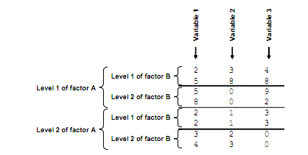

Perform the test and report (cope / paste) the entire results file below.

Report the pseudo-F values, the p values and the pair-wise tests.

Was there a significant interaction between the two factors? Why / why not? Explain.

