Multivariate Statistics (MARS6300) - Homework 4 Name: _______________________
Distributed: Sunday, February 25, 2018 Due: Thursday, March 8, 2018

Instructions: Copy and paste your answers below and turn in a word file and two excel files by the end of due day via email to khyrenba@gmail.com. Please use email title “MARS 6300 hw#4” and label all files with you’re a suffix including your name (e.g., MARS6300_hw4_hyrenbach). Unlabeled emails / files will be penalized 10% of points.

You are free to use any reference materials of your choice. While you are encouraged to work together, make sure you turn your own assignment. This homework is worth 5 points.

The objectives of this homework are:
A) To review and practice NMDS.
B) To investigate the effects of species on NMDS results.
C) To perform and interpret NMDS analyses.
D) To critically evaluate the NMDS literature.

To complete this homework, you will need:
- Instruction file: “BIOL6300_hw4.doc” (open with word file) – turn in
- “IndianOceanSeabirds.xls” data file: (open with excel) – do not turn in
(Note: matrix 1: “bird data” sheet, and matrix 2: “env data” sheet)

- Assessing Species / Sample Dominance (1 point):
Import matrix 1 and matrix 2 from the excel file.

Use the column / row summary tool in PC_ORD and calculate column / row
totals for the data in matrix 1. Paste the results below:
First, lets look at the row summaries.
- Are there any empty plots (without any species recorded)? Which one? ___
- What metric (hint: letter variable) tells you how many species are found per plot? ___
What is the range of species found per plot? ___________

- How are the four metrics of species “diversity” related to each other? Calculate pair-wise cross correlations (hint, use CORREL in Excel) of the four variables: S, E, H, D`

 | S | E | H | D’
S | 1
E | - | 1
H | - | - | 1
D | - | - | - | 1

Is Shannon species diversity more closely driven by species richness or evenness? Explain:

Is Simpson species diversity more closely driven by species richness or evenness? Explain:

Next, lets look at the column summaries.

- Are there any empty columns (any “absent” species)?

- What species (indicate four letter acronym) is the most numerous: _____

How large is its sum of abundance (birds / km 2) across all 16 samples: ______

- What species (indicate four letter acronym) are only sighted in one sample: _____

- How many (%) cells are empty? ____

- What are the mean skewness for species: _____ and for plots: ______

- On the basis of the inspection of the data, would you use PCA or NMDS for its analysis?
Could a transformation yield normal distributions, given the high proportion of “zeros”? Explain:

- Why would you remove the plots / species from the dataset you identified above?

- To remove the plots / species, do the following:
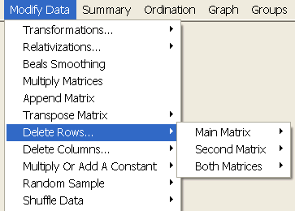
- Remove the species first, using the “delete columns” command. Request that species with only one presence to be removed. How many species were discarded: _______

- Copy and paste the “results.txt” output here:

- Next, check again if there are any “empty” samples after removing these species. Are there any empty plots?

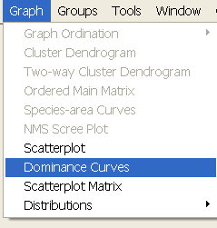
2) Selecting the species to be analyzed (1 point):
The species in the dataset vary greatly, on basis of their density (birds / km 2). Use the “dominance curves” command to assess the species relative abundance.
Inspect the “results.txt” file. You can save the “results.txt” file and open with Excel. Use these data to test whether the ranks of species abundance and the ranks of species frequency are correlated. Report r: ____

Paste the curve of “sum” versus “rank abundance” here:

Using the data in the “results.txt” file to calculate proportions of abundance for each species.
Paste an excel table, showing the ranked (from most abundant to least abundant) species (column 1) and their relative abundance (column 2) and the cumulative relative abundance (column 3).
species | Sum | % | cumm
GWPT | 413.98 | 26.36 | 26.36
TOTAL |  | 100 | 100

How many species – together – make up 95 % of all the bird abundance? _____
How many species – together – make up 100 % of all the bird abundance? _____
How many species make up, at least 1% of the total bird abundance? _____
How many species make up, at least 5% of the total bird abundance? _____

Make a plot, showing the relative abundance of the different species and report the descriptive statistics for those species-specific proportions of abundance. Based on these graph and statistics, what thresholds would you use to identify “numerous”, “common” and “rare”, species? Explain your rationale:

3a) NMDS analysis with entire dataset - 16 plots and 36 species (0.75 points):
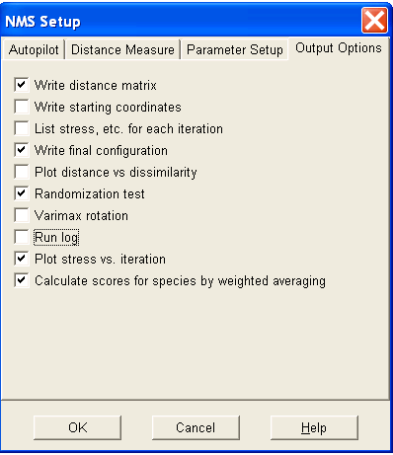
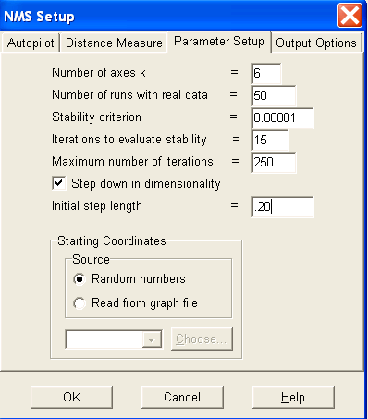
Use the following parameter set-up and output:

What distance measure would you use? Why?
How many runs will you select to get a p value as small as 0.001? Explain?
At the end of the “results.txt” file you will find the recommended solution. How many dimensions does PC-ORD recommend? __________

Copy and paste the NMS scree plot here:

Does this result make sense with the two “criteria” we discussed in class? Paste the STRESS IN RELATION TO DIMENSIONALITY (Number of Axes) table and explain your answer.

If we did not use the stress reduction rule, how many axes would the best solution have on the basis of the significance level (p < 0.05) of the randomizations ?

Paste the PLOT OF STRESS V.ITERATION NUMBER for recommended dimension answer
(Remember, your answers may vary slightly from those of your colleagues):

Did the iterations stop before 250? Why / why not?

Create a plot, using the “Graph \ Graph Ordination” command. Add environmental vectors – scaled to 100%.

Request amount of variance in distance matrix explained. Copy and paste the results below:

Report the orthogonality of the two axes:

Request the correlations with the environmental variables. Copy and paste the results below:

Interpret these results:
- Which environmental variables best explain the two main axis of variation?

3b) MNDS analysis of reduced dataset – with the “core of the community”: 16 plots and 21 species (so total proportion of all birds sighted is over 95%) (0.75 points).
Note: Remove the following species:
BRSK | CAPT | DPSP | GBSP | GHAL
KEPT | KIPN | LTJA | NGPT | ROPN
SGPT | SOSH | WBSP | WFSP | WHPT
Use the following parameter set-up and output:

What distance measure would you use? Why?
How many runs will you select to get a p value as small as 0.001? Explain?
At the end of the “results.txt” file you will find the recommended solution. How many dimensions does PC-ORD recommend? __________

Copy and paste the NMS scree plot here:

Does this result make sense with the two “criteria” we discussed in class? Paste the STRESS IN RELATION TO DIMENSIONALITY (Number of Axes) table and explain your answer.

If we did not use the stress reduction rule, how many axes would the best solution have on the basis of the significance level (p < 0.05) of the randomizations ?

Paste the PLOT OF STRESS V.ITERATION NUMBER for recommended dimension answer
(Remember, your answers may vary slightly from those of your colleagues):

Did the iterations stop before 250? Why / why not?

Create a plot, using the “Graph \ Graph Ordination” command. Add environmental vectors – scaled to 100%.

Request amount of variance in distance matrix explained. Copy and paste the results below:

Request the correlations with the environmental variables. Copy and paste the results below:

- Did the results change from what you found in question 3a? In particular, how did the amount of variance explained change? Does this make sense? Hint: As you restrict the definition of the “community”, how does this affect the dissimilarities between samples and the total variance in the ordination?

3c) MNDS analysis of reduced dataset – without “rare” species. Using the criteria you selected before to identify and remove the rare species, identify and remove additional species from your list (0.75 points).
Note: List the species you will remove from the dataset:
______________________________________________________________________________
Report how many species and plots are included in the analysis (Hint: Did you lose any plots that were left empty when you removed those “rare” species ? __________________
Use the following parameter set-up and output:

What distance measure would you use? Why?
How many runs will you select to get a p value as small as 0.001? Explain?
At the end of the “results.txt” file you will find the recommended solution. How many dimensions does PC-ORD recommend? __________

Copy and paste the NMS scree plot here:

Does this result make sense with the two “criteria” we discussed in class? Paste the STRESS IN RELATION TO DIMENSIONALITY (Number of Axes) table and explain your answer.

If we did not use the stress reduction rule, how many axes would the best solution have on the basis of the significance level (p < 0.05) of the randomizations ?

Paste the PLOT OF STRESS V.ITERATION NUMBER for recommended dimension answer
(Remember, your answers may vary slightly from those of your colleagues):

Did the iterations stop before 250? Why / why not?

Create a plot, using the “Graph \ Graph Ordination” command. Add environmental vectors – scaled to 100%.

Request amount of variance in distance matrix explained. Copy and paste the results below:

Request the correlations with the environmental variables. Copy and paste the results below:

Did the results change from what you found in question 3a? In particular, how did the amount of variance explained change? Does this make sense? Hint: As you remove “rare” species, how does this affect the dissimilarities between samples and the total variance in the community?

4) Document your data modifications (0.5 points):
Create a log, where you describe the manipulations you did to accomplish questions 2 and 3 above. A diagram is not needed, but make sure you provide a detailed sequential description of the steps that you took and how each step changed the dataset you were working with.

5) Critical reading of the literature (1 point): Read these papers (Lopez et al. (2014), Brodeur et al. (2011), Yildirim et al. (2010), Aswani (2005)) and report the following:

* Lopez et al. 2014:
- Describe what type of data were analyzed? Where they quantitative / categorical / both?
- How many axes were involved in the “best answer”? How were they selected?
- Did the paper report p values for the axes? If they did, how many randomizations were used?
- Did the paper report the variance explained by the axes? How large was the total % variance?

* Brodeur et al. 2011:
- Describe what type of data were analyzed? Where they quantitative / categorical / both?
- How many axes were involved in the “best answer”? How were they selected?
- Did the paper report p values for the axes? If they did, how many randomizations were used?
- Did the paper report the variance explained by the axes? How large was the total % variance?

* Yildirim et al. 2010:
- Describe what type of data were analyzed? Where they quantitative / categorical / both?
- How many axes were involved in the “best answer”? How were they selected?
- Did the paper report p values for the axes? If they did, how many randomizations were used?
- Did the paper report the variance explained by the axes? How large was the total % variance?

* Aswani 2005:
- Describe what type of data were analyzed? Where they quantitative / categorical / both?
- How many axes were involved in the “best answer”? How were they selected?
- Did the paper report p values for the axes? If they did, how many randomizations were used?
- Did the paper report the variance explained by the axes? How large was the total % variance?

