Abstract. Echinoids are important to coral reefs because they maintain ecosystem health and influence changes in the structure of the community. Collector urchins, Tripneustes gratilla, were planted across 12 patch reefs in Kaneohe Bay to aid in the reduction of invasive algal species. After the outplanting of the T. gratilla, previous studies have suggested that the abundance of the urchins have declined; however, the cause is unknown. To understand the decline in T. gratilla, water quality samples and substrate transects were performed at two out planted reefs (30 and 38) in North Kaneohe Bay. This paper presents the trends that were present amongst water quality and substrate availability/utility at these two reefs. The findings pertaining to salinity and temperature measurements at the two reefs were marginally significant; whereas, the turbidity measurements were not significant due to high variability. Substrate availability (rock, coral, sand, algae) were dependent on a) water quality and b) distance from Kahalu’u Stream. Substrate electivity was calculated using Ivlev’s Index and indicated that urchins preferred algae on Reef 38, and rock on Reef 30. All other substrate types were avoided by the urchins, including rock at Reef 38. In conclusion, water quality and substrate availability could be potential reasons for the decline in T. gratilla. Water quality and substrate availability will need to be evaluated at more locations across Kaneohe Bay to better understand this urchin decline and the effects on reef health.

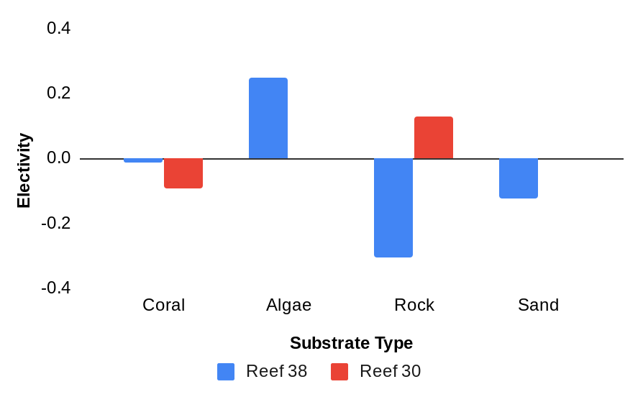
Figure 1. Substrate Electivity of T. gratilla in North Kaneohe Bay. All substrate and urchin observations were made at two reefs, Reef 38 and Reef 30. Reef 38 is represented by blue bars and Reef 30 is represented by red bars.

Available substrate types (coral, algae, rock, sand) were compared to the substrates that T. gratilla were observed on. In order to make this comparison, Ivlev’s Index was used. This index is normally used to show preference in feeding behaviors amongst predators (Ivlev 1961); however, was employed to calculate substrate preference. This index ranges from -1 to 1 (Ivlev 1961). Any values that were calculated and negative, represented avoidance of a substrate; whereas, positive values represented a preference (Ivlev 1961). The two patch reefs were compared to understand how the preference of T. gratilla varied with the substrate(s) available. Reef (38) is closer to Kahalu’u Stream, which infers that more algae would be found on this reef. The other patch reef (30) is further from Kahalu’u Stream; however, has a higher wave impact than Reef 38, which infers that harder substrate types will be found here. On Reef 38, all substrate types were observed, however, algae was the substrate type preferred by the collector urchins. On Reef 30, only two of the substrate types (coral, rock) were observed. T. gratilla preferred rock on this patch reef. This preference in substrate types between the two patch reefs is related to distance from freshwater input from Kahalu’u Stream.

Keywords: Tripneustes gratilla, Kaneohe Bay, water quality, substrate availability, substrate utility, Kahalu’u Stream.

