Student name: ________ _KEY______________________

This assignment is worth 5 points. You will use the data file “MARS4040-6040_Diet.xls” file to perform the analyses / figures using excel or another graphing / stats program of your choice. This assignment is due, by email to khyrenba@gmail.com (use “MARS4040-6040 Diet Analysis” as the title) by midnight of Nov. 8, 2016. Late submissions will be penalized 10% of the credit for each day. NOTE: Use the formulas in these two references: Hart et al. 2002 and Brown et al. 2012.

- Summarize the proventriculus diet data (including plastic) for the 10 shearwaters, using descriptive statistics (mean, median, standard deviation, minimum, maximum), and create six histograms of the number / mass of the two prey types (fish / squid / plastic).
(+0.25 for each: fish / squid / plastic).
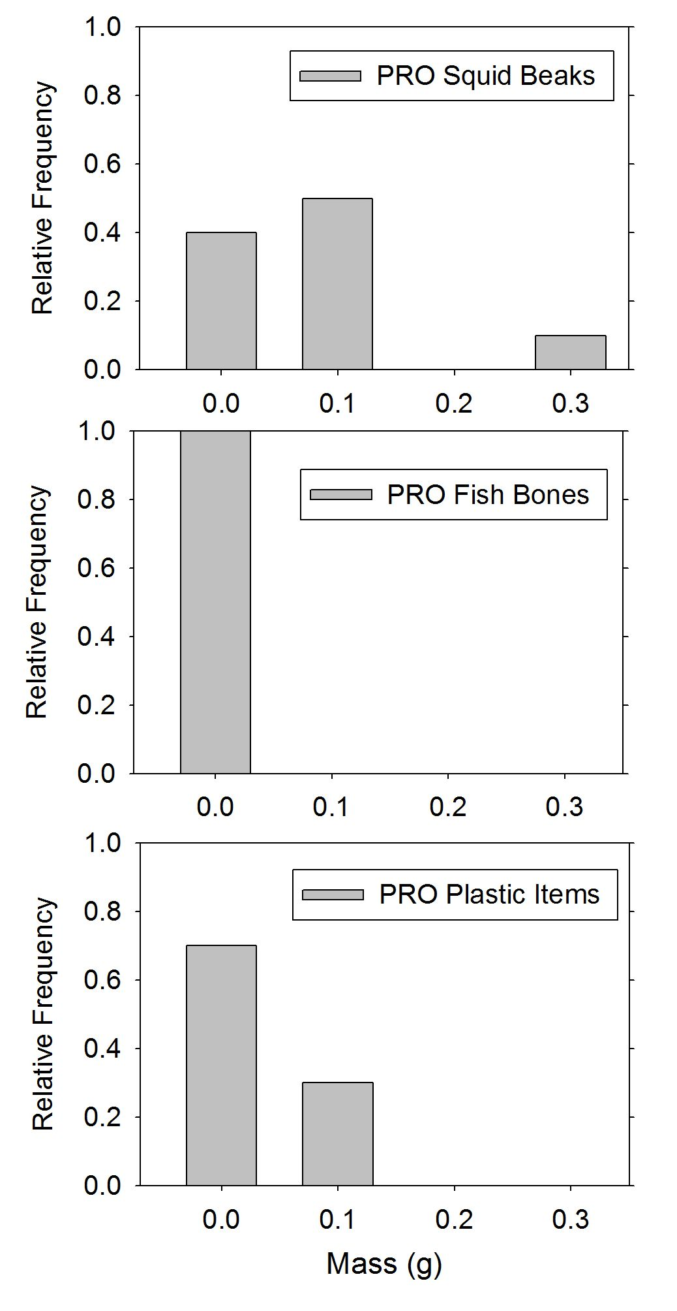
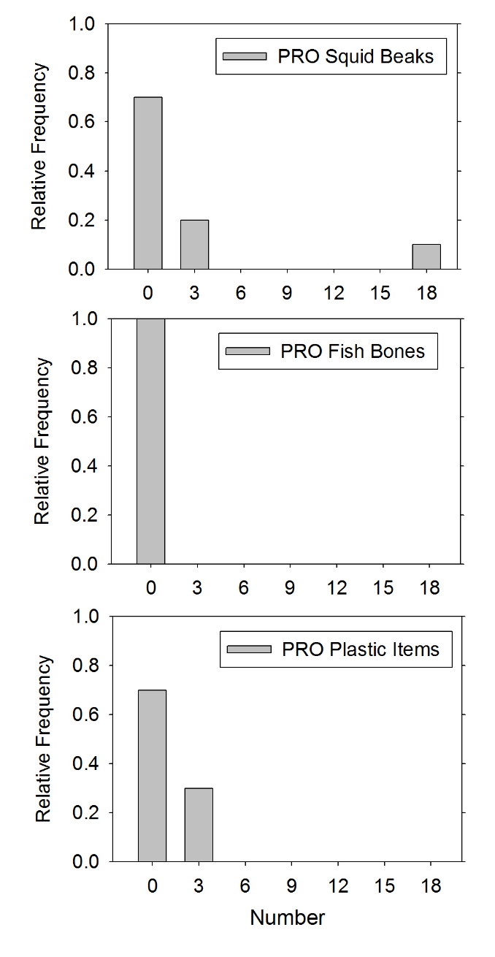

PRO | squid_beak_# | fish_bones_# | plastic_#
mean | 2.3 | 0.0 | 0.6
S.D. | 6.3 | 0.0 | 1.3
median | 0.0 | 0.0 | 0.0
min | 0 | 0 | 0
max | 20 | 0 | 4

PRO | squid_beak_mass_g | fish_bone_mass_g | plastic_mass_g
mean | 0.065 | 0.000 | 0.025
S.D. | 0.106 | 0.000 | 0.049
median | 0.050 | 0.000 | 0.000
min | 0.00 | 0.00 | 0.00
max | 0.35 | 0.00 | 0.15

- Summarize the gizzard diet data (including plastic) for the 10 shearwaters, using descriptive statistics (mean, median, standard deviation, minimum, maximum), and create six histograms of the number / mass of the two prey types (fish / squid / plastic).
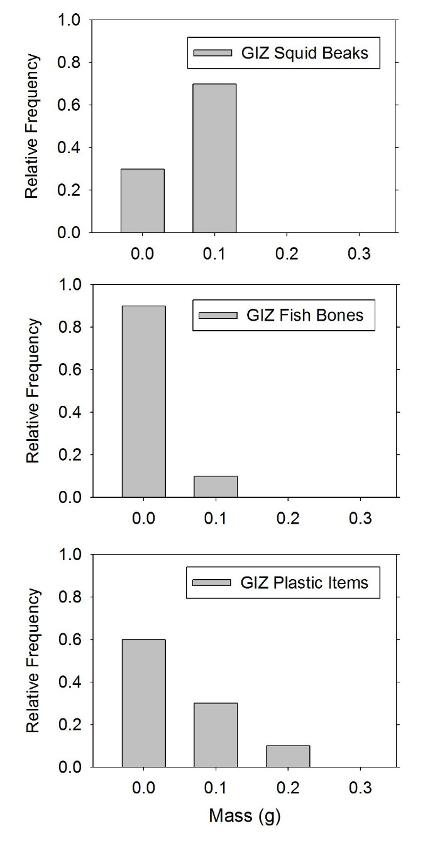
(+0.25 each: fish / squid / plastic).
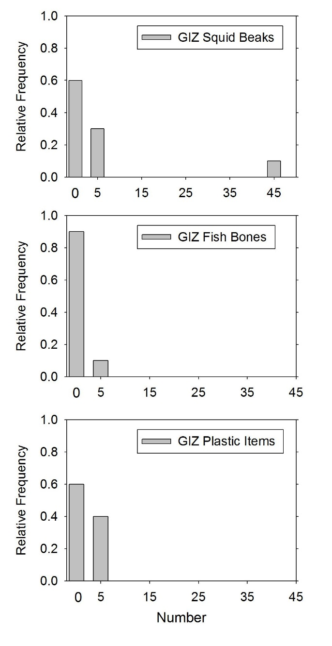

GIZ | squid_beak_# | fish_bones_# | plastic_#
mean | 7.0 | 0.2 | 1.4
S.D. | 15.6 | 0.6 | 2.8
median | 0.0 | 0.0 | 0.0
min | 0 | 0 | 0
max | 50 | 2 | 9

GIZ | squid_beak_mass_g | fish_bone_mass_g | plastic_mass_g
mean | 0.050 | 0.005 | 0.035
S.D. | 0.041 | 0.016 | 0.063
median | 0.050 | 0.000 | 0.000
min | 0.00 | 0.00 | 0.00
max | 0.10 | 0.05 | 0.20

- Calculate the following metrics for the proventriculus contents, (including squid beaks, fish bones and plastic): % occurrence, % mass, % number, IRI, %PSIRI (+0.25 each type). What is the most important prey item in proventriculus? Why? (use results to justify answer) (+0.25).

PRO | squid | fish | plastic | TOTAL
% occurrence | 60.00% | 0% | 60.00% | 120%
%  number | 79.31% | 0% | 20.69% | 100%
%  mass | 72.22% | 0% | 27.78% | 100%

Squid is the dominant item in the proventriculus: it occurs in 60% of the samples and accounts for 79.31% (by number) and 72.22% (by mass). Plastic occurs at low levels and there are no fish remains.

PRO | squid | fish | plastic
Occurrence | 60.00% | 0% | 30.00%
Number | 79.31% | 0% | 20.69%
Mass | 72.22% | 0% | 27.78%
IRI | 9091.8 | 0.0 | 1454.1
%IRI | 86.2% | 0.0% | 13.8%

IRI = (%Number + %Mass) * (%Occurrence) and %IRI = 100% * (IRI / Σ (IRI))

IRI_squid = 60 * (79.31 + 72.22) = 9091.8 %IRI_squid = 9091.8 / (9091.8 + 1454.1) = 86.2%
IRI_plastic = 60 * (20.69 + 27.78) = 2908.2 %IRI_fish = 2908.2 / (9091.8 + 1454.1) = 13.8%
IRI_fish = 0 * (0 + 0) = 0 %IRI_fish = 0 / (9091.8 + 1454.1) = 0.0%

Plastic had 30% relative occurrence, a total number of 6 and a total mass of 0.25 g.
Squid had a 60% relative occurrence, a total number of 23 and a total mass of 0.65 g.
There was no fish remains in the proventriculus samples.
Thus, squid is more frequent and abundant (by mass and number) than plastic in the proventriculus.

For the calculation of the %PSIRI, we only use those samples where each species occurred:

%PSIRI = [ (%PN + %PV) * %FO ] / 2
PN = numerical percentage
PV = volumetric percentage (or mass)
FO = frequency of occurrence

PRO | squid_# | fish_# | plastic_# | squid_mass_g | fish_mass_g | plastic_mass_g
%PA | 98.41 | - | 68.25 | 86.67 | - | 60.00

%PSIRI_squid = [ (%PN + %PV) * %FO ] / 2
%PSIRI_squid = [ (98.41 + 86.67) * 0.6 ] / 2
%PSIRI_squid = [ 185.08] / 2 = 55.52%

%PSIRI_plastic= [ (%PN + %PV) * %FO ] / 2
%PSIRI_plastic = [ (68.25 + 60.00) * 0.3 ] / 2
%PSIRI_plastic = [ 128.25] / 2 = 19.24%

NOTE: the %PSIRI for fish = 0 (its not found in any samples)

- Calculate the following metrics for the gizzard contents, (including squid beaks, fish bones and plastic): % occurrence, % mass, % number, IRI, %PSIRI (+0.25 each type). What is the most important prey item in gizzard? Why? (use results to justify answer) (+0.25).

GIZ | squid | fish | plastic | TOTAL
%  Occurrence | 70.00% | 10.00% | 40.00% | 120%
%  Number | 81.40% | 2.33% | 16.28% | 100%
%  Mass | 55.56% | 5.56% | 38.89% | 100%

Squid is the dominant item in the gizzard, occurring in 70% of the samples and accounts for 81.40 % by number and 55.56% by mass of the stomach contents. Plastic is the second most frequent and numerous item (by both mass and volume). There are also fish remains in the gizzard. While only 10.00% of the samples have fish remains, this item accounts for 2.33% by number and 5.56% by mass.

Overall, when focusing on prey: squid has 99% of the importance, and fish has 1% of the importance.

IRI = (%Number + %Mass) * (%Occurrence) and %IRI = 100% * (IRI / Σ (IRI))

IRI_squid = 70 * (81.40 + 55.56) = 9587 %IRI_squid = 9587 / (9587 + 79 + 9665) = 49.6%
IRI_plastic = 40 * (16.28 + 38.89) = 9665 %IRI_plastic = 9665 / (9587 + 79 + 9665) = 50.0%
IRI_fish = 10 * (2.33 + 5.56) = 79 %IRI_fish = 79 / (9587 + 79 + 9665) = 0.4%

GIZ | squid | fish | plastic
Occurrence | 70% | 10% | 40%
Number | 81.40% | 2.33% | 16.28%
Mass | 55.56% | 5.56% | 38.89%
IRI | 9587 | 79 | 9665
%IRI | 49.6% | 0.4% | 50.0%

For the calculation of the %PSIRI, we only use those samples where each species occurred:

%PSIRI = [ (%PN + %PV) * %FO ] / 2
PN = numerical percentage
PV = volumetric percentage (or mass)
FO = frequency of occurrence

PRO | squid_# | fish_# | plastic_# | squid_mass_g | fish_mass_g | plastic_mass_g
%PA | 91.73 | 100.00 | 35.52 | 78.57 | 100.00 | 87.50

%PSIRI_squid = [ (%PN + %PV) * %FO ] / 2
%PSIRI_squid = [ (91.83 + 78.57) * 0.7 ] / 2
%PSIRI_squid = [ 170.30 * 0.7 ] / 2 = 59.60%

%PSIRI_plastic = [ (%PN + %PV) * %FO ] / 2
%PSIRI_plastic = [ (35.52 + 87.50) * 0.4 ] / 2
%PSIRI_plastic = [ 123.02 * 0.4 ] / 2 = 24.60%

%PSIRI_fish = [ (%PN + %PV) * %FO ] / 2
%PSIRI_fish = [ (100 + 100) * 0.1 ] / 2
%PSIRI_fish = [ 200 * 0.1 ] / 2 = 10%

Plastic had 40% relative occurrence, and a total number of 14 and total mass of 0.35 g.
Squid had a 70% relative occurrence, a total number of 70 and a total mass of 0.50 g.
Fish had a 10% relative occurrence, a total number of 2 and a total mass of 0.05 g.
Thus, squid is more frequent and abundant (by mass and number) than plastic and fish in the gizzard.

- Using the albatross data in the sheet entitled “laal_boluses_categories”, determine which of the three categories (food, natural non-food, non-natural) most closely determines the overall size of a bolus. Hint: I am not asking for the relative masses of the categories, but for the category whose mass varies more strongly with overall bolus mass. Explain your answer. (+0.20).

Relative composition of the boluses – by mass. The boluses are, on average, made up of natural food remains (51.05%), non-natural items (31.22%) and natural nonfood items (17.73%).

 | Natural_food_g | Natural_NonFood_g | Non-Natural_g
mean | 51.05 | 17.73 | 31.22
std | 18.93 | 11.39 | 15.76
median | 51.77 | 18.50 | 26.34
min | 10.89 | 0.07 | 14.56
max | 84.18 | 34.69 | 63.25

However, determining which one of the three bolus components most closely determines the overall size, involves performing three regressions and figuring out which component is best correlated with the bolus size. In other words, which regression yields the largest r-squared.

Bolus Component | R squared | p value
Natural_food | 0.009 | 0.785
Natural_NonFood | 0.619 | 0.004
Non-Natural | 0.568 | 0.007

Natural NonFood is the component most closely related to the total mass of the bolus. There is a significant relationship between the mass of a bolus and the mass of natural nonfood it contains.

Moreover, on average, 51.05 +/- 18.93 S.D. of the mass of a bolus is natural food remains. This small CV = 37.08% (S.D. / mean) underscores the low variability in the mass of nonfood remains in boluses.

Non-Natural (plastics) is the second component most closely related to the total mass of the bolus.
There is a significant relationship between the mass of a bolus and the mass of plastic it contains.
Yet, this pattern is driven by a single 37.7 g bolus, which contained 22.6 g of plastic.

Moreover, on average, 31.22 +/- 15.76 S.D. of the mass of a bolus is natural food remains. This small CV = 50.48% (S.D. / mean) underscores the low variability in the mass of nonfood remains in boluses.

The mass of Natural Food remains is not correlated with the total mass of the bolus.

Moreover, on average, 17.73 +/- 11.39 S.D. of the mass of a bolus is natural food remains. This large CV = 64.26% (S.D. / mean) underscores the high variability in the mass of nonfood remains in boluses.

- Using the albatross data in the sheet entitled “bolus”, determine which is the most “important” prey item (fish or squid). For full credit, back-up your answer using quantitative metrics and base your answer on the basis of your results (+1).

First, I would combine all types of squid prey remains and all types of fish prey remains:
Then, I would calculate the frequency of occurrence of squid and fish:
While every bolus contains squid remains, only 36.36% include fish remains

 | PRESENCE
 | SQUID | FISH
 | 1 | 0
 | 1 | 1
 | 1 | 0
 | 1 | 0
 | 1 | 1
 | 1 | 0
 | 1 | 0
 | 1 | 0
 | 1 | 0
 | 1 | 1
 | 1 | 1
sum | 11 | 4
FO | 100% | 36.36%

Next, I would compare the relative number and mass of squid / fish prey items in the boluses:

 | NUMBER |  |  | MASS
 | SQUID | FISH | TOTAL | SQUID | FISH | TOTAL
 | 111 | 0 | 111 | 8.996 | 0 | 8.996
 | 404 | 7 | 411 | 13.676 | 0.004 | 13.68
 | 88 | 0 | 88 | 4.104 | 0 | 4.104
 | 130 | 0 | 130 | 8.06 | 0 | 8.06
 | 222 | 1 | 223 | 18.657 | 0.0005 | 18.6575
 | 218 | 0 | 218 | 11.266 | 0 | 11.266
 | 236 | 0 | 236 | 7.077 | 0 | 7.077
 | 70 | 0 | 70 | 4.706 | 0 | 4.706
 | 484 | 0 | 484 | 14.532 | 0 | 14.532
 | 277 | 1 | 278 | 6.541 | 0.0005 | 6.5415
 | 193 | 11 | 204 | 9.247 | 0.26 | 9.507
Sum | 2433 | 20 | 2453 | 106.862 | 0.265 | 107.127
% Abundance | 99.18 | 0.82 |  | 99.75 | 0.25

Overall, squid makes up 99.18% of the prey (by number) and 99.75% of the prey (by mass).

Next, I would integrate these three metrics into a single index, using the %PSIRI.

To do this, I calculate proportions of squid / fish in each bolus – for mass / number separately.
Remember, I only use those boluses where each prey type is present, for the %PA calculations:

%NUMBER |  |  | %MASS
SQUID | FISH | TOTAL | SQUID | FISH | TOTAL
100.000 | 0.000 | 100.000 | 100.000 | 0.000 | 100.000
98.297 | 1.703 | 100.000 | 99.971 | 0.029 | 100.000
100.000 | 0.000 | 100.000 | 100.000 | 0.000 | 100.000
100.000 | 0.000 | 100.000 | 100.000 | 0.000 | 100.000
99.552 | 0.448 | 100.000 | 99.997 | 0.003 | 100.000
100.000 | 0.000 | 100.000 | 100.000 | 0.000 | 100.000
100.000 | 0.000 | 100.000 | 100.000 | 0.000 | 100.000
100.000 | 0.000 | 100.000 | 100.000 | 0.000 | 100.000
100.000 | 0.000 | 100.000 | 100.000 | 0.000 | 100.000
99.640 | 0.360 | 100.000 | 99.992 | 0.008 | 100.000
94.608 | 5.392 | 100.000 | 97.265 | 2.735 | 100.000

 | NUMBER |  |  | MASS
 | SQUID | FISH |  | SQUID | FISH
%PA | 99.282 | 1.976 |  | 99.748 | 0.694
%FO | 1 | 0.4 |  | 1 | 0.4

%PSIRI_squid = [1 * (99.282 + 99.748) ] / 2 = 99.515 %

%PSIRI_fish = [0.4 * (1.976 + 0.694) ] / 2 = 0.534 %

