NOTE: Do not Turn This In. Homeworks will not be graded
Homework in preparation for quiz #2 – on October 8
When answering the following questions, make sure you show all your calculations to get full (or partial) credit. Insert text in the spaces provided, between the yellow highlight. Make figures using a drawing software (suggest using paint or powerpoint) and insert your picture into the text.
1) Define the following terms and when applicable, provide a formula (+0.25, each):
- Geometric Mean =
- Median =
- Variance =
- 75% percentile =
- 99% Confidence Interval =
2) Report the following parameters for these samples: median, mode, mean, S.D., variance. Show all your work to get full (partial) credit: (+0.1 each parameter):
Dataset a: 1,2,3,4,5
Median:
Mode:
Mean:
S.D.:
Variance:
Dataset b: 3,3,3,3,3
Median:
Mode:
Mean:
S.D.:
Variance:
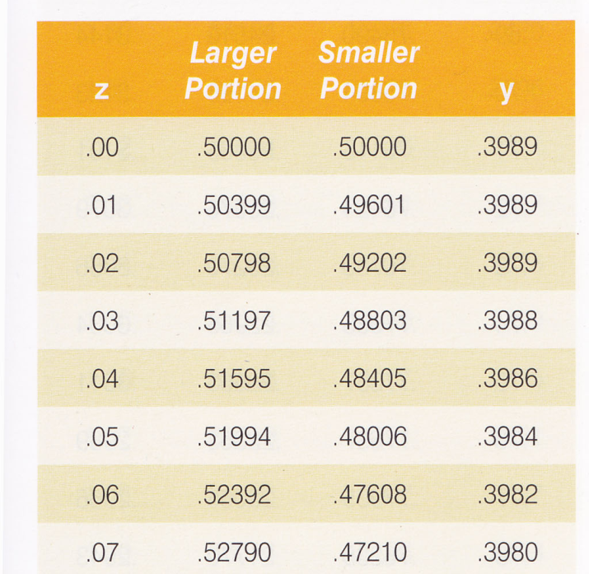

3) Using the portion of the Z-score table provided, calculate the following probabilities
(+0.25 each) Show your work (reasoning) to get full credit:
- P (Z >0.00) = ___
- P (Z <0.00) = ___

P ((Z<0.04) OR (Z>0.07))= __

P ((Z<0.04) AND (Z>0.07))= __

P ((Z>0.04) AND (Z<0.07))= __

P ((Z>0.04) AND (Z>0.07))= __

4) Adult males in a certain country are known to have heights, which are normally distributed with a mean of 175.6 cm and a SD of 7.63 cm. If you select an adult male from this population at random, what is the probability that: (i) his height lies between 175 and 185 cm, and (ii) if you select 6 males from this population at random, at least 4 will have heights between 175 and 185 cm? (+0.25 each) Note, for this question, you will need to use the Z-score table in Appendix 1 of your textbook.

(ii) What is probability that, If you pick 6 males, at least 4 are in this size range (considered “success”)

5) You randomly sample 100 cats in O’ahu and measured their tails. The mean tail length = 19.8 cm and the S.D. = 4.8 cm. Calculate the following parameters using these data (+0.25 each):
- Coefficient of Variation (CV):

- Standard Error (S.E.):

- 96% Confidence Interval (CI):

- 68% Confidence Interval (CI):

